Chapter 14, Solution 102.

- When 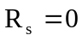 and 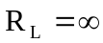, we have a low-pass filter.

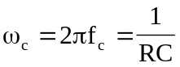
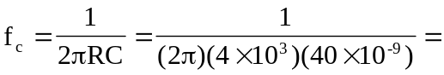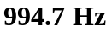

- We obtain 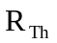 across the capacitor.
